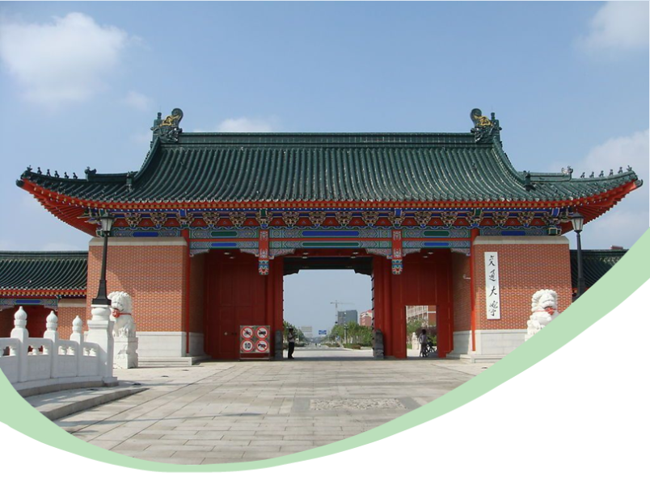

Soft Matter for Energy Conversion and Storage
Shanghai Jiao Tong University International Summer School
Program(（July 17-19, 2015）

Organizer: School of Chemistry and Chemical Engineering
Shanghai JiaoTong University
Soft Matter for Energy Conversion and Storage
Shanghai Jiao Tong University International Summer School Program（July 17-19, 2015）
July 18, 2015 (Saturday), Academic Activity Center, SJTU
9:15-9:30 | Opening ceremony and welcome remarks (Jiesheng Chen)
9:30-10:30 | Session 1  Chair: Deyue Yan
9:30-10:00 | Hua Zhang, Nanyang Technological University, Singapore  Synthesis and Applications of Novel Two-Dimensional Nanomaterials
10:00-10:30 | Xinchen Wang, Fuzhou University, China  Two-dimensional Soft Photocatalysts for Solar Energy Conversion
10:30-11:00 | Photography & Coffee break

11:00-12:00 | Session 2  Chair: Pingkai Jiang
11:00-11:30 | Qichun Zhang, Nanyang Technological University, Singapore  Synthesis, characterization and applications of heteroacenes
11:30-12:00 | Xiaoyu Huang, Shanghai Institute of Organic Chemistry, CAS, China  TBA
12:00-14:00 | Lunch

14:00-15:45 | Session 3  Chair: Wende Xiao
14:00-14:30 | Chao Gao, Zhejiang University, China,  Graphene-based supercapacitors and Li-S Cells
14:30-15:00 | Yanwu Zhu, University of Science  and Technology of China, China  Graphene Based Materials for Highly Efficient Energy Storage and Conversion
15:00-15:30 | Guqiao Ding, Shanghai Institute of Microsystem and Information Technology, CAS, China  Large scale synthesis of graphene materials
15:30-15:45 | Coffee break

15:45-17:15 | Session 4  Chair: Fangming Jin
15:45-16:15 | Feng Liu, Xi’an Jiao Tong University  Complex self-assembly of block molecules with different topologies
16:15-16:45 | Fengwei Huo, Nanjing Tech University  The Design of Metal-Organic Framworks for catalysis
16:45-17:15 | Teng Ben, Jilin University, China  Porous Polymers: Targeted Design and Application Study
18:00 | Dinner

July 19, 2015 (Sunday), Academic Activity Center, SJTU
9:30-11:00 | Session 1  Chair: Xinyuan Zhu
9:30-10:00 | Junhe Yang, University of Shanghai for Science and Technology  Graphene-based thin film materials: preparation and application
10:00-10:30 | QuanHong Yang, Tianjin University, China  From soft sheet to hard framework: densifying graphene for EES
10:30-11:00 | Dingcai Wu, Sun Yat-sen University, China  Fabrication and application of novel porous polymer and carbon materials
11:00-11:15 | Coffee break

11:15-12:15 | Session 2  Chair: Qinghua Lu
11:15-11:45 | Huisheng Peng, Fudan University, China  Fiber-shaped energy harvesting and storage devices
11:45-12:15 | Xinhua Zhong, East China University of Science and Technology, China  Quantum Dot Sensitized Solar Cells
12:15-14:00 | Lunch

14:00-15:30 | Session 3  Chair: Shunai Che
14:00-14:30 | Xiaodong Chen, Nanyang Technological University, Singapore  Inorganic Nanogels for Ultrafast Charging Lithium Ion Batteries
14:30-15:00 | Yanlei Yu, Fudan University, China  Photodeformable liquid crystal polymers and bioinspired applications
15:00-15:30 | Jiajun Gu, Shanghai Jiao Tong University  Plasmonic Applications of 3D Metallic Structures Replicated from Butterfly Scales
15:30-15:45 | Close (Sixun Zheng)

15:45-17:15 | Campus and Lab tours
17:15 | Dinner
Location: 1).Academic exchanges center, Shanghai Jiao Tong University, 2).Shanghai Hhuhua International Hotel
会议地址：上海交通大学闵行校区学术活动中心（阶梯会议厅）

组委会：（有问题请及时拨打下列组委会老师和同学的电话）
负责人：张帆 老师 （手机：13524024225）
成员：吴东清 老师 （手机：13661543628）
麦亦勇 老师 （手机：18930796745 ）
邱丰 老师（手机：15021217608）
王新扬 同学（手机：15000203321）
张文贝 同学（手机：13122182618）
毕帅 同学（手机：18801970371）
热烈欢迎各位老师和同学莅临上海交通大学!
⎯For “Friendship (友谊) 、Learning(学习)、 Communication (交流) 、Collaboration(合作)”

Conference Hotel 会议酒店
Shanghai Huhua International Hotel
上海沪华国际大酒店
NO.300 Heqing Road， Shagnhai， China
中国上海鹤庆路300号
Tel：（86）（021）61268299
联系电话：（86）（021）61268299
Web：http://www.huhuahotels.com
网址：http://www.huhuahotels.com

Registration 会议报到/注册
Time：Friday, July 17, 2015
时间：2015年7月17日，星期五
Location: 1).Academic exchanges center, Shanghai Jiao Tong University, 2).Shanghai Hhuhua International Hotel
具体地址：上海交通大学学术活动中心
（注：7月17日报到的参会教师也可直接到上海沪华国际大酒店办理入住和注册手续）

Attendees with “attendance confirmation” (A4 typing paper) can get conference materials, including mainly attending badges, conference handbook, dining coupons, ect, at the sign-desk
参会人员凭《参会确认函》 （A4纸打印件）到签到处领取相关会议资料， 主要包括： 参会胸卡、会议手册、校园停车卡等

Parking 停车
Self-parking (Complimentary)
上海交通大学校园内自助停车（免费）

Route ( To Shanghai Jiao Tong University, Minhang campus)
路线（至上海交通大学，闵行校区）
1 ).From Shanghai Hongqiao International Airport or Shanghai Hongqiao Railway Station
Bus: No.4 of Hongqiao Transport Hub to Jiao Tong University station
Taxis: About 70CNY
1). 从上海虹桥国际机场或者虹桥火车站出发
公交：虹桥枢纽4号线，到交大（闵行）站下
出租车：约70元人民币
2 ).From Shanghai Pudong International Airport
Taxis: About 150CNY
Subway: Shanghai Metro Line 2 to People square station,chage to Line 1 to Xinzhuang station, change to Line 5 to Dongchuan station
2) 从上海浦东国际机场出发
地铁：乘地铁2号线至人民广场站，换乘1号线至莘庄站，再次换乘5号线至东川路站下
出租车：约150元人民币
3 ).From Shanghai Railway Station
Subway: Shanghai Metro Line 1 to Xinzhuang station, change to Line 5 to Dongchuan station
Taxis: About 100CNY
3) 从上海火车站出发
地铁：火车站乘地铁1号线到莘庄站，换乘地铁5号线至东川路站下
出租车：约100元人民币
